Figure 5.7 Initial version of the DevOps Implementation framework Agile-based SPOs

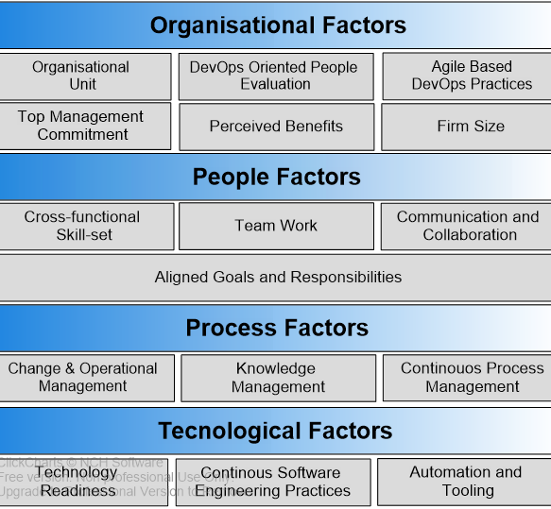

Figure 5.8 Updated version of the DevOps Implementation framework for Agile-based SPOs

